TABEL CATAGORIES

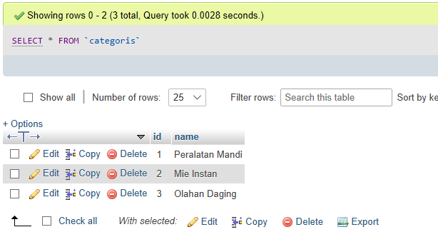

TABEL PRODUCTS

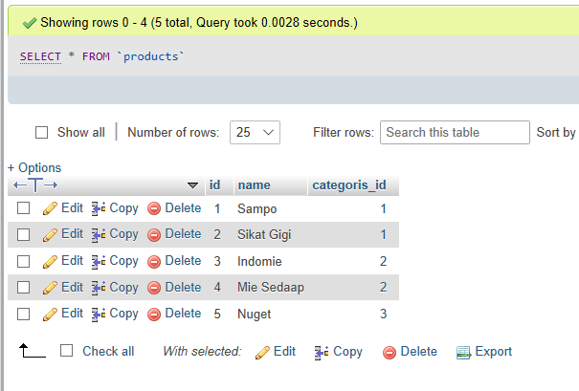

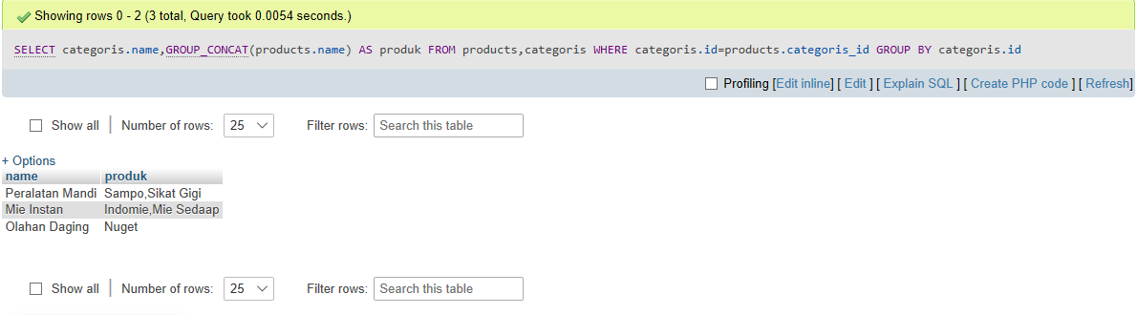

**B. Query :**

**SELECT categoris.name,GROUP_CONCAT(products.name) AS produk FROM products,categoris WHERE categoris.id=products.categoris_id GROUP BY categoris.id**